Loan default analysis

This paper analyses a dataset issued by AnalysisHorizon Financial Group with over 600 personal loans across 2024 and 2025. The company has noticed that roughly 1 in 4 loans are defaulting, which is well above their target of 12%.

The overall average default rate was 24.3 %. In the picture below you can see the different default rates per loan type, with Auto Loan, Home Improvement and Wedding are the types of loans with the highest default rate.
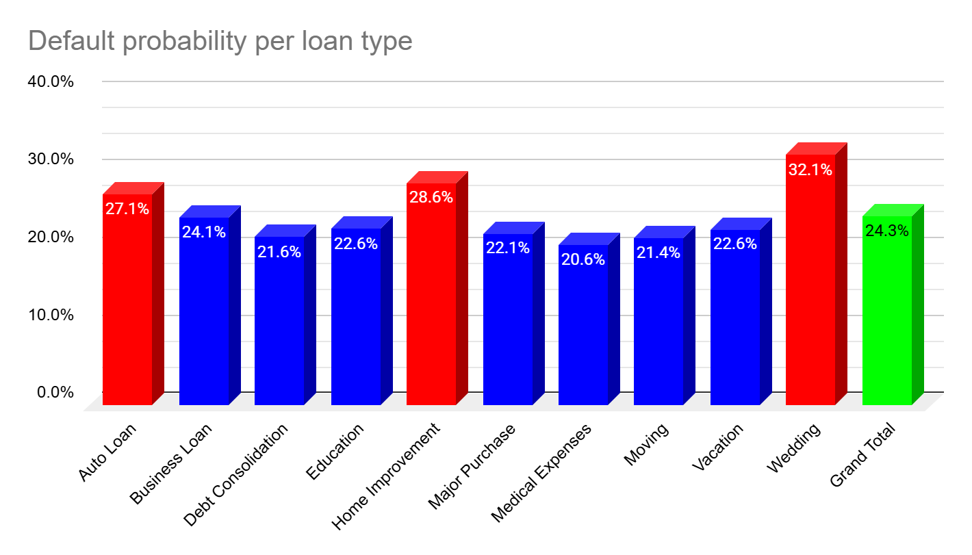
The highest risk factors for the loans under investigation are credit score, DTI ratio and interest rate. The diagram below shows the relationship between credit score and default probability.

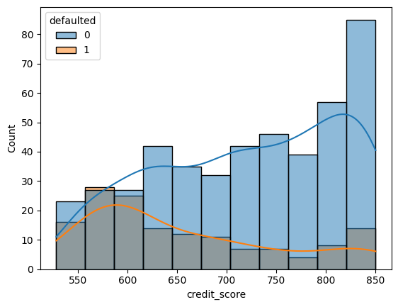
Credit scores below 625 are significantly more likely to default.

The interest rate has also a significant impact, as shown in the following diagram:

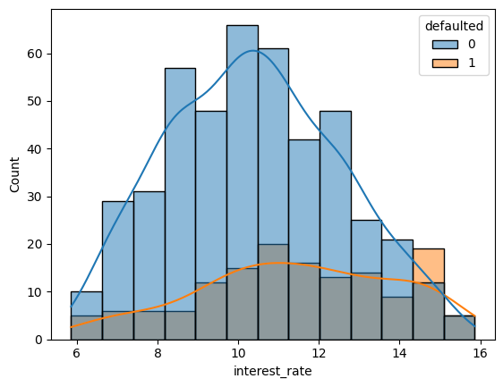
The last factor with significant impact is the DTI ratio.

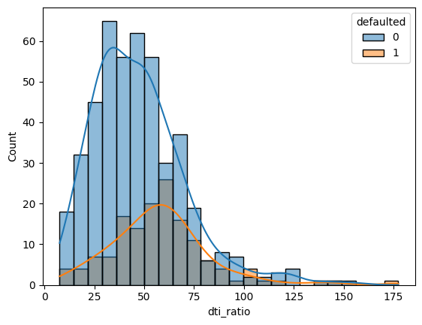
For higher DTI ratio values the markers for defaulted loans and closed loans are closer together, therefore the default ratio increases.

The loan amount has an impact as well, as seen in this diagram:

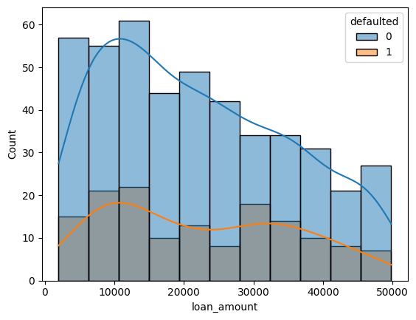

The loan amount is not a great limiter, as large loans are closed with a reasonable probability.

If we only consider loans with a credit score larger than 625 and an interest_rate smaller than 13.5 and a DTI ratio smaller than 60, then we can reduce the default percentage to 12.97%

The detailed numbers can be found here:

portfolio/alex_the_analyst_loan_default.ipynb at main · Alan-Turing-33/portfolio

